





BrandProtect is a brand company, which embodied technologies of block chain and cryptoprotection in real sector of the economy.

We use block chain technology to ensure the protection of intellectual property rights of trademark owners, prevent counterfeiting and protect consumers from counterfeit goods.

We create an ecosystem that provides the creation and functioning of hardware and software packages of products, interaction platforms with logistic robots, network and geolocation monitors, smartphone apps marking.

BrandProtect platform allows generating the necessary for the user apps and program products, crypto markers for products (digital or QR code), branded smartphone application from any part of the world within minutes. As well as to launch and use all the functionality embedded in them.

The information about the origin of items, its characteristics, and properties, terms of its usage, transportation is written in the block chain and stored within the distributed roster ensures immutability, availability, transparency and full replication of data.





We live in the world of consumerism.

People want to get as much as they can. Every moment can provide a great number of manufacturing goods and foodstuffs.



The Brandproject platform creates the ecosystem of block chains, which is going to protect the property rights, transparency, replication and efficient use for sellers and buyers.

Labelling, creation of quality certificates and compliance with the brand, crypto markers for products (digital or QR code), hardware and software packages of products, interaction platforms with logistic robots, creation and mobile APP use for certificates and geolocation transfer have never been so easy and cheap.

The usage of block chain technology gives a way to create individual information markers for manufacture goods and foodstuffs, drugs. It helps to make it instantly, with a low price, which is very important nowadays. In addition, it provides the transactions through the individual means of communication.

The label owner can choose the level of the platform usage, from crypto markers to the replication with their trademark. It also allows creating a corporate blockchain.

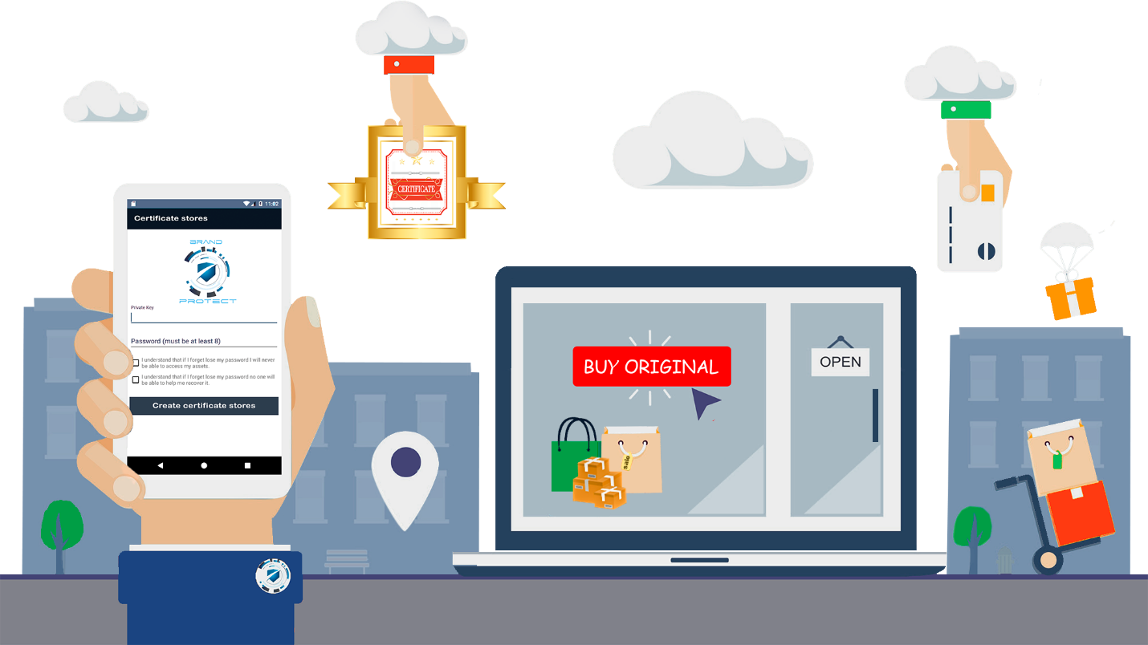



- The platform user using the web App in the Brandprotect`s website brandproject.pro, registers the trademark - brand. Upon that creates an account with private key protected by the cryptographic protocol KECCAK-256.

- Under each brand, you can create a “blockchain certificates” the number of which corresponds to the number of units in the consignment, product information, release date and end date of use, as well as various additional information.

- The seller of goods, at each transaction of purchase-sale, transfers to the buyer the corresponding quantity of blockchain certificates, through the mobile application.

- The buyer sees the received blockchain certificates and information encrypted in them through his mobile App. That allows verification of brand originality for online or offline purchases.

- Further integration of our platform with payment systems gives the customer an opportunity to confirm the originality of the brand at the time of purchase automatically or block payment in the case of not confirming the originality of the product.

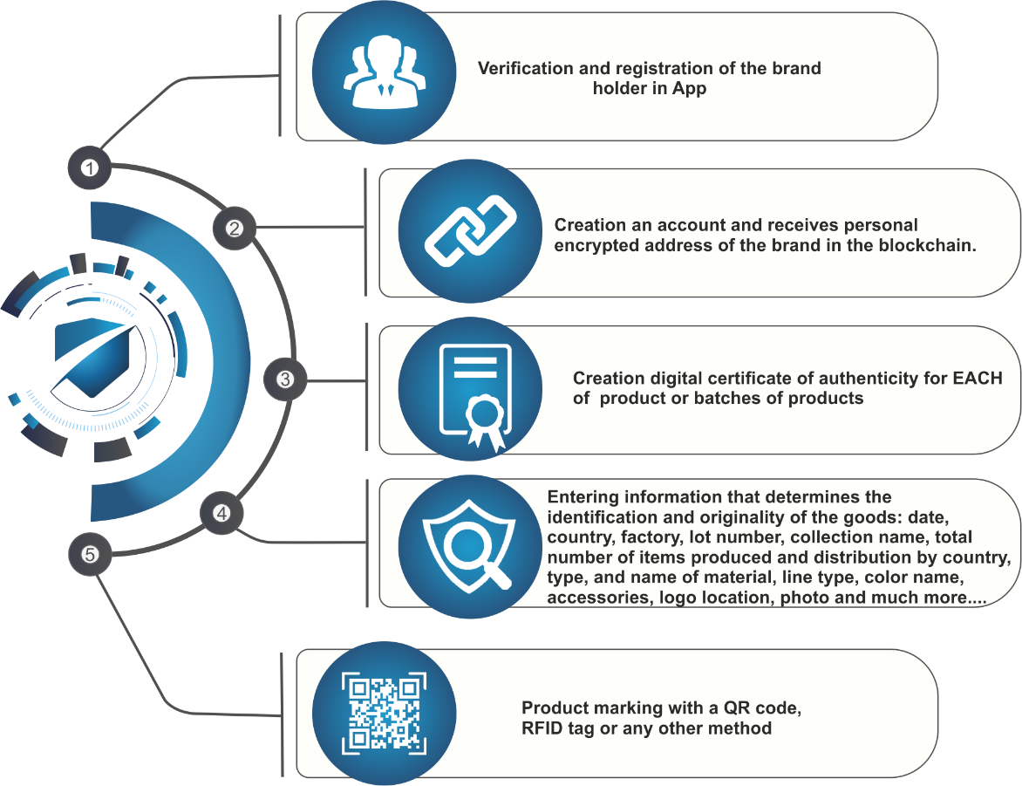



-The platform user may not register the brand to create a commercial party “consignment”. This creates unique blockchain identifiers of the goods in the quantity of the consignment. The identifiers are coded in QR code, which allows them to be applied to each unit of the product by laser marker or sticker.

The buyer scanning the QR code receives all the information about the product made while creating a consignment.

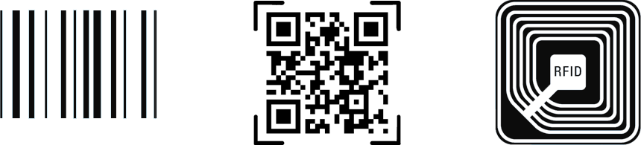



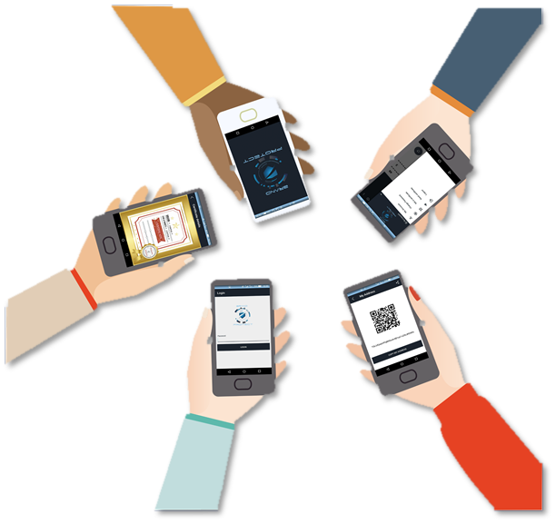



The BrandProtect is a B2B & B2C platform.

BrandProtect.pro is created for all participants of the consumer market.

The latest information technologies, blockchain and cryptography technologies make this market transparent, protecting the interests of buyers and sellers.





Our team has performed a great job within the last 18 months. We created a technological platform, which is a practical use of blockchain technologies and IOT in an actual sector (production, trade, logistics, and consumer).

Currently, the platform is functioning in TRON blockchain network. Considering risks of TRON network usage and potentially great development prospects we decided to launch our own blockchain network BrandProtect.

The implementation of Brand Protect in the world economy is our next goal.

Registration of trademarks, legal entity in the Swiss jurisdiction, marketing activities require substantial funding.

15,000,000 BRAND tokens are issued for our project financing.

First stage. Pre-Sale of BRAND tokens.

7% of total amount of BRAND tokens are put on sale.

Number of tokens for sale = 1,050,000 BRAND tokens

Start bonus – 33%

Starting price - $ 0.5 for 1 BRAND token

The second stage of financing will be held through IEO on a few stock exchanges.

For now, we already have approvals from two stock exchanges.

14% of coins will be put on sale.

Number of tokens for sale =2,100,000 BRAND coins

Early investors get the opportunity to fix the profit or continue their participation in our project.

Third stage of financing

This stage is held on the background of our platform incorporation into marketing plans of different enterprises.Announcing partnerships will be a good sales engine for the third stage of financing.

30% of coins will be put on sale.

Number of coins for sale = 4,500,000 BRAND

IEO STRUCTURE

|  |  |  |
| --- | --- | --- |
| Pre-Sale Starts | 08/28/2019 | |
| Pre-Sale Period | 209 days | |
| Pre-Sale Cap | $525 000 | |
| Pre-Sale Bonus | 33% | |
| IEO Starts | 04/27/2019 | |
| IEO Period | 30 days | |
| Soft Cap | $520 000 | |
| Hard Cap | $1,365,000.00 | |
| Token Symbol | BRAND | |
| Total Number of Tokens | 15,000,000.00 | |
| Exchange Rate | 1BRAND=0.5 USD | |
| Minimum Purchase | fiat currency | crypto currency |
| $50 | $10 |
| Accepted fiat | yes | |
| Accepted Сryptos | BTC, ETH,EOS,TRX | |
| Listing | BRAND tokens will be listed on cryptoexchanges | |
| Token Holder Benefits | BRAND you can use to pay for services on BrandProtect platform. | |

TOKEN DISTRIBUTION

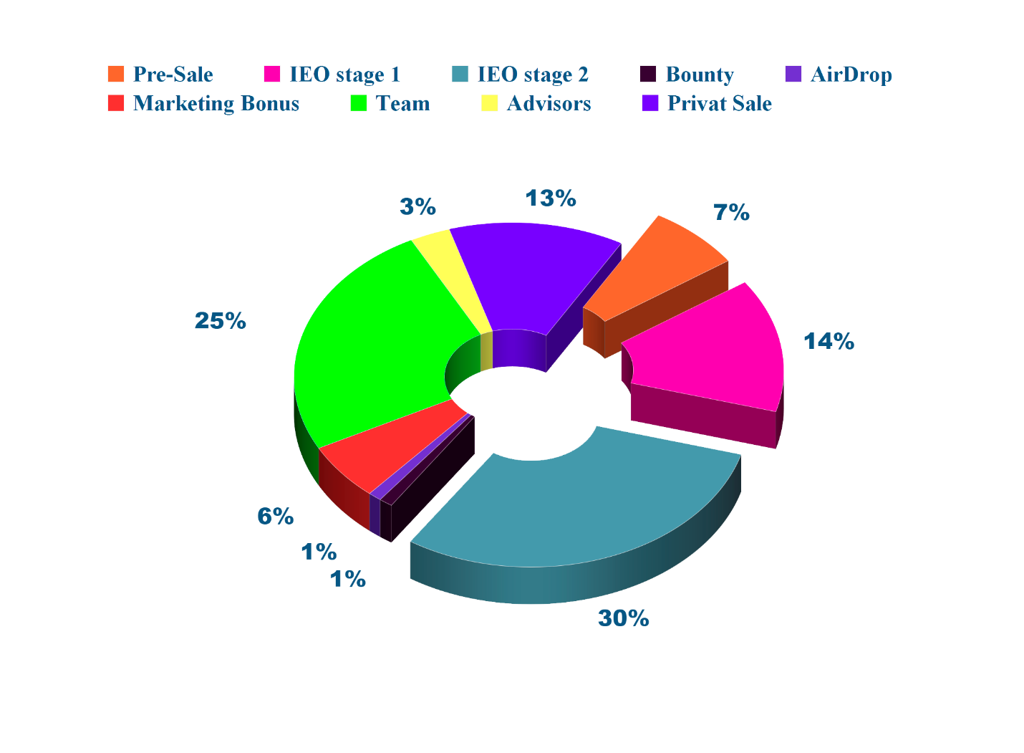



We have developed a software and hardware environment for the operation of the BrandProtect platform. The stages of our work are reflected in this road map. Join the embodiment of the future!

